Kindergarten  Items we will share as a class- no names needed  - 36 yellow #2 pencils  - 8 large Elmer’s Disappearing Glue Sticks  - 2 boxes of crayons (24 count)  - 3- 4 count boxes of dry erase markers  - 4 two-pocket folders (yellow, green, red, and blue)  - 4 boxes of Kleenex  - 3 containers of Clorox/Lysol wipes  - 2- 100 count packages of index cards  - 2 packages of paper towels  - 1 box of sandwich sized Ziploc bags  - 1 box of gallon sized Ziploc bags  Items students will keep at their desks-names needed  - 1 pencil box  - 2 spiral notebooks-wide ruled  - 1 pointed tip scissors  - 2 changes of clothes with names on the tags  - Headphones or earbuds | First Grade  Items we will share as a class- no names needed  - 36 yellow #2 pencils  - 8 large glue sticks  - 2 boxes of crayons (24 count)  - 2 boxes of dry erase markers  - 4 two-pocket folders (yellow, red, purple, and blue)  - 4 boxes of Kleenex  - 1 bottle of hand sanitizer (largest size possible)  - 1 container of Clorox wipes  - 3 pack big pink erasers  Items students will keep at their desks- names needed  - 1 pointed tip scissors  - 1 pencil box  - 2 spiral notebooks- wide ruled  - 4 composition notebooks | Second Grade  Items we will share as a class- no names needed  - 5 boxes of crayons (24 count)  - 40 yellow pencils  - 8 glue sticks (large size)  - 4 large boxes of tissue  - 2 bottles of hand sanitizer  - 1 roll of paper towels  - 1 pack of yellow highlighters  - 1 box of Band-Aids  - 2 packs of Clorox wipes  - 2 boxes of Ziploc bags (girls-sandwich, boys-gallon)  - 2 boxed of dry erase markers  - 2 large pink erasers (no pencil toppers)  - 3 blue plastic folders (no prongs)  - 2 packs of index cards  Items students will keep at their desks- names needed  - 2 pair of scissors  - 2 boxes of washable color markers  - 1 backpack (no wheels)  - 1 plastic pencil box  - 4 composition notebooks (no spiral bound)
Third Grade  - 1 backpack  - 1 pack of loose leaf paper (wide ruled)  - 3 composition notebooks (no spirals)  - 3 plastic folders (yellow, red, and blue)  - 36 #2 pencils (no mechanical pencils)  - 4 – 4 packs of dry erase markers  - 2 large glue sticks  - 1 pair of scissors  - 1 plastic pencil pouch  - 1 plastic pencil box  - 2 packs of crayons (24 count)  - 1 box of colored pencils  - 1 box of washable markers (optional)  - 2 large erasers or a package of small erasers  - 4 boxes of Kleenex  - 1 bottle of hand sanitizer  - 1 ruler  - 1 clipboard  - 1 container of Clorox/Lysol wipes  - 1 box of Ziploc bags (boys-gallon, girls-sandwich)  - 1 pack of yellow highlighters  - 1 pack of Post-it Notes  - Headphones  Donations: paper towels, dry erase spray cleaner, and highlighters | Fourth Grade  - 2 large bottles of hand sanitizer  - 1 backpack  - 48 #2 pencils  - 6 plastic folders  - 5 spiral bound notebooks  - 2 pink erasers  - 1 ruler  - 2 packs of large glue sticks  - 1 clipboard  - 1 pack of highlighters  - 1 pair of scissors  - 2 boxes of crayons (24 count)  - 1 pack of washable markers (not small)  - 3 packs of loose-leaf paper (wide ruled)  - 4 large boxes of tissue  - 3 rolls of paper towels  - 2 packs of dry erase markers  - 1 box of Ziploc bags (boys-sandwich, girls-gallon)  - 1 box of Band-Aids  - 2 packs of index cards  - 2 containers of antibacterial wipes | 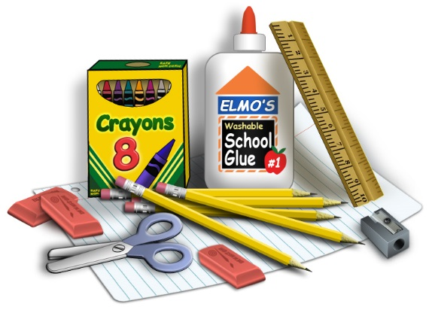
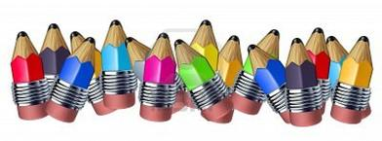
ALL STUDENTS NEED AN OLD SHIRT OR SMOCK.

